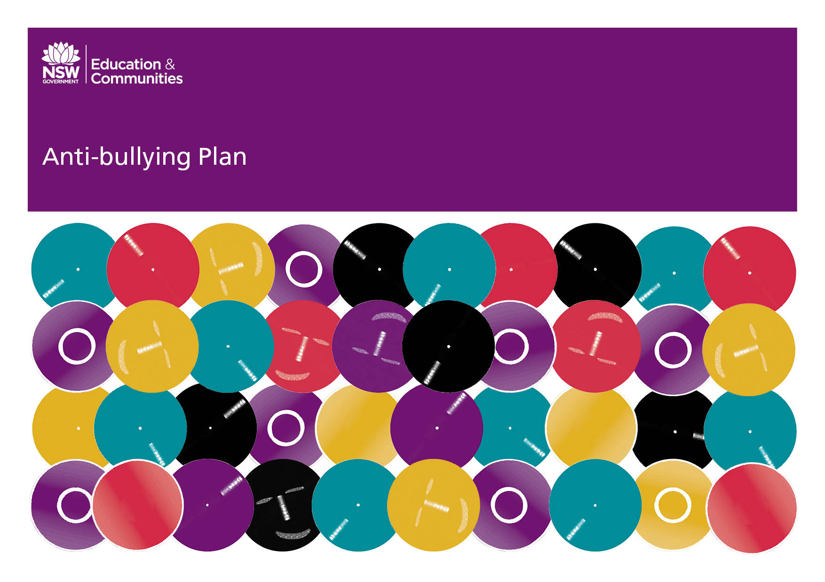

Leura Public School
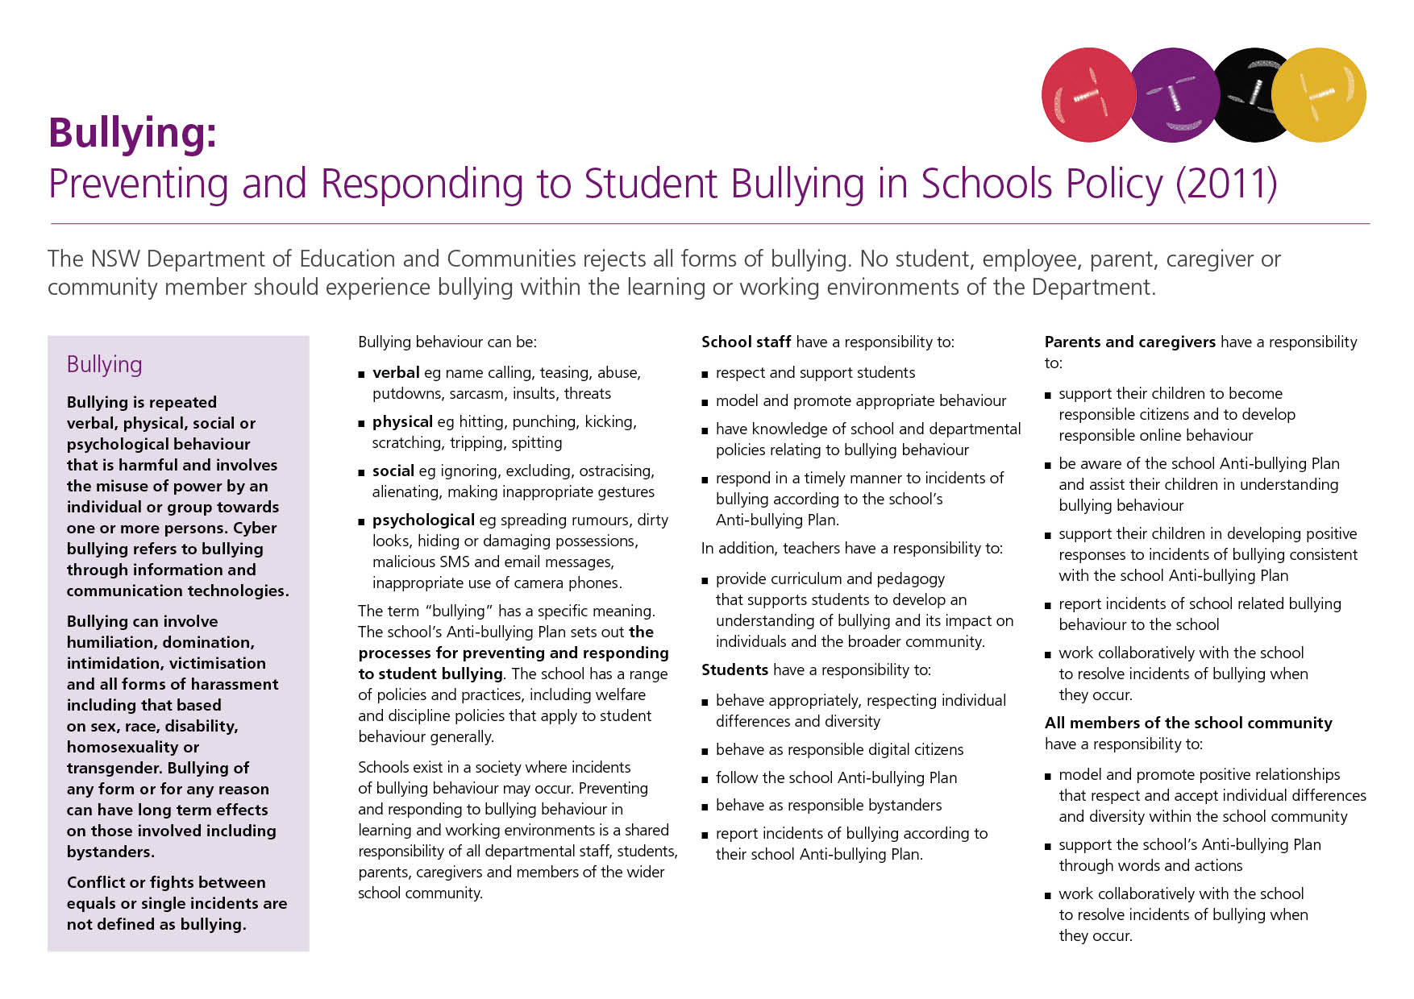
Our School Anti-Bullying Plan
Leura Public School Anti-Bullying Plan
This plan outlines the processes for preventing and responding to student bullying in our school and reflects the Bullying: Preventing and Responding to Student Bullying in Schools Policy of the New South Wales Department of Education and Communities.
The development of this plan began when the staff of Leura Public School considered these three questions;

What do we already do that works?
What do we do that needs reviewing?
What do we need to add?

Students and parents were also asked the same questions. A small community focus group assisted in this process. The plan was created from the whole school community’s feedback. This will be the tool that is used to review and update the school’s plan on a regular basis.
Statement of purpose
Leura Public School has a strong sense of community and enjoys the high involvement of families in their child’s education. Our community accepts individual differences and our school provides an environment where each child is empowered to reach their full potential academically and socially.
Leura Public School is a Positive Behaviour for Learning School (PBL). Our core values are:
Respect Responsibility Resilience
Our ultimate purpose is to build a culture of learning and support that builds respectful, resilient and responsible global citizens, who can make a positive impact on 21st Century Australia.
At Leura Public School we acknowledge that bullying can, at times, occur. It is our aim to work together to create a school culture that does not accept bullying in any form. It is the responsibility of all stakeholders, school staff, school students and school families to support the collaboratively developed strategies in this plan.

The school community defines bullying behaviour with quite specific features:

- REPEATED harmful verbal, physical, social or psychological behaviour.

- Misuse of power by an individual or group towards one or more persons.

- Acts that involve racial, religious or cultural discrimination.

- The use of information technologies in or out of school that affects a student’s psychological well being or social relationships at school. i.e. cyber-bullying.

- Bystander behaviour that impacts directly on the bully and/or the victim.

Isolated incidents are not considered bullying, however, any single act of aggression, intimidation or exclusion still needs to be reported and dealt with under the school’s welfare and discipline policy and the procedures outlined in this plan.

The school acknowledges that in some situations, an isolated incident that is not dealt with effectively may turn into bullying behaviour at a later date.

Protection
Rights and Responsibilities
Students, parents, caregivers, teachers and members of the wider community have individual and shared responsibilities to create a happy and safe learning environment, free from all forms of bullying.
All of these stakeholders have the right to:
- be free of the fear of harassment, intimidation and exclusion;
- be treated with respect at all levels of communication;
- have their reports of bullying behaviour responded to within an acceptable time frame;
- be provided with appropriate support when bullying occurs;
- be part of the collaborative development of the anti-bullying plan;
- know what is expected of them in relation to this plan.

All of these stakeholders have the responsibility to:

- engage and interact respectively in positive relationships that accept individual differences and diversity within the whole school community;
- promptly report any bullying behaviour that is causing concern;
- work together to resolve incidents of bullying;
- contribute to the development/review of the school’s anti-bullying plan;
- act in accordance with this plan.

Students have the responsibility to:

- behave according to the PBL Expectations Matrix;
- engage in appropriate bystander behaviour;
- Speak out against bullying.

Staff have the responsibility to:

- explicitly teach respect, responsibility and resilience in line with the behaviour expectations matrix;
- model respectful relationships and have classrooms existing as anti-bullying bastions;
- respond promptly and consistently to an incident of bullying behaviour;
- teach collaboratively designed anti-bullying lessons each year;
- ensure effective supervision of students at all times;
- inform parents of the appropriate protocol for reporting bullying behaviour;
- collect and analyse data to identify patterns of bullying behaviour;
- participate in professional learning that keeps them up to date about anti-bullying strategies in schools.

Parent/Carers have the responsibility to:
- Support the school by knowing the content of the anti-bullying; plan, following the procedures and encouraging and modelling respectful relationships;
- support their children in developing positive and appropriate strategies to respond to incidences of bullying;
- encourage their children to reject bullying by using the NO GO TELL strategy taught at school;
- promptly report any concern through the appropriate school channels.

Positive Relationships
Schools form networks of relationships;
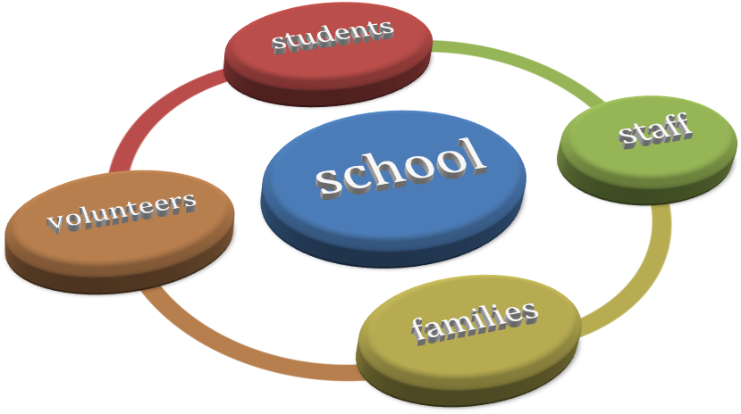

Through the PBL program, the school actively promotes and rewards positive interactions and expects that all stakeholders will be mutually respectful in all situations.

How does this happen?
Each of these groups are supported by school wide systems.

For students:
- creating a matrix of expected positive behaviour in every school setting;
- specifically teaching the expected behaviours;
- reinforcing expected behaviours through the school wide positive reward system;
- using universal positive language when communicating behavior expectations;
- having clear consequences for unacceptable behaviour;
- celebrating success for displaying positive behaviour through a reward system.

For families:
- Teachers establishing and maintaining formal and informal contact with families;
- Publishing values award recipients in newsletters and inviting families to assembly presentations;
- Offering timely feedback and updates when contact has been made;
- Consulting with parents/carers on policies and issues surrounding the welfare of the students at our school.

For staff:
- Communicating to staff plans that are in place to support individuals, groups and families;
- Ensuring staff have access to professional learning that equips them to create inclusive programs that cater for student diversity.

Prevention
The school implements the following strategies and programs for bullying prevention:
- Peer Support Program run yearly that has a focus on positive relationships, making friends and caring for each other;
- PBL lessons explicitly teaching expected behaviours that reinforce respect, responsibility and resilience;
- Cumulative award system that promotes and rewards positive behaviour;
- Cyber safety through class, Library and Police Youth Liaison lessons;
- Series of anti-bullying lessons taught at the beginning of each year. These units focus on:
  - Definition of bullying
  - Assertiveness training using the NO GO TELL strategy
- Tell the person NO (universal hand signal)
if that doesn’t work
- walk away from them
if that doesn’t work
- tell a teacher
  - Bystander behaviour
  - Reporting procedures;
- Use of visual aids (commercial and student made), that reinforce anti-bullying messages and fair play;
- Mobile phones, iPads and iPods must be checked in at the school office;
- Providing play equipment for use on playground;
- Buddy systems and class activities throughout the year;
- Consistent implementation of the universal prevention guide (see appendix);
- Inclusive snippets in the school’s newsletter about how to deal with bullying behaviour.
It is important to note that no single method of bullying prevention has been reported as 100% effective; more than one strategy will usually have to be implemented. To this end, anti-bullying messages are embedded into the school’s Positive Behaviour for Learning program, which is reinforced in all school settings daily.
Early Intervention
Leura Public School will implement the following strategies and programs to support students who are identified as being at risk of developing long-term difficulties with social relationships, and those students who are identified at or after enrolment as having previously experienced bullying or have engaged in bullying behaviour:
- Referral to our school Learning Support Team for intervention and planning from School Counsellor, Learning and Support Teacher or School Learning Support Officer;
- Collection and analysis of data to identify patterns of bullying behaviour;
- Implementing the ‘Play Pal’ program to deal with low level incidents in the playground (peer mediation);
- Encouraging parents to approach the school in a timely manner if they are concerned about bullying;
- Encouraging students to report bullying behavior to school staff. School staff will respond appropriately and refer matters of a serious or ongoing nature to school executive;
- Communicating the process to school families for responding to and reporting bullying behaviour on our school website and in the newsletter;
- Implementing ‘Play Club’ in K-2 and ‘Cooperative Games’ in 3-6 to promote positive social interactions.
Response.
What do I do if my child says they have been bullied at school?
It is vey common that a child will report an incident of bullying to a parent or carer rather than directly to a staff member.
Talk to the classroom teacher. The teacher is in the best position to deal with a problem directly as they have day-to-day contact with the students involved. The teacher will let the school executive know that an issue has been raised.

What happens next?
Step 1
The teacher or school executive will investigate the report. This may involve speaking to other students, speaking to staff members, examining school data etc. This should be completed within 2-3 days after the report has been made.
Step 2
Parents of all students involved will be contacted.
Step 3
Resolution procedures will be put in place using the school’s Student Well-Being policy and Department of Education and Communities Discipline Policy. These procedures will be communicated to all stakeholders including parents/carers and all staff.
Step 4
Class teacher/school executive will closely monitor situation over the next 4 weeks:
- Staff will have regular contact with students to assess effectiveness of procedures;
- A follow-up call will be made to reporting family within 2 weeks of the resolution procedures being implemented, to ensure that procedures are being followed and are having success.

Step 5
Continue to monitor via school data and intermittent contact with students where necessary.
When is more support needed?
Where an incident has occurred of a serious nature, further support may be necessary for victims, witnesses or antagonists. These may include:
- Individual management plans that include specific strategies for playground and classroom;
- Investigation by the school’s Anti – Racism Contact Officer (a member of staff who has been trained in the procedures);
- Referral to outside agencies that offer assistance with child wellbeing and mental health issues.
- Reporting to Police, Community Services or the DEC Child Well Being Unit.
Evaluation
The school will evaluate this plan yearly, adding and refining interventions and support mechanisms where necessary.
Every three years, there will be a revision of the plan involving members of the school community.

Principal’s comment
This Anti-Bullying Plan has been developed by the staff of Leura Public School in consultation with our students and the school community. Bullying of any kind has no place in our school and all measures will be taken to ensure student’s well-being and safety. We expect our school to be a safe place for students to learn and teachers to teach.

School Executive
Nathan Smith – Relieving Principal
Paula Forrester – Assistant Principal K-2
Stephen Atkinson – Assistant Principal 3-6
Margaret McMahon – Assistant Principal

School Contact Information
Leura Public School
Cnr Mt Hay Road & Willow Park Ave
Leura 2780

Ph: 4784 1251
Fax: 4784 3156
Email: www.leura-p.schoolsnsw.edu.au
Website: http://www.leura-p.schools.nsw.edu.au/

Additional Information
School Youth Liaison Officer – Ring Springwood Police Station on 02 4751 0299 and ask for extension 74268
Katoomba Police Station – 02 4782 8199
DOCS Helpline – 133 627
DET Safety Response – 1300 363 778
Kids Helpline – 1800 55 1800

